RRRRR
Re: Letter of Student Traveler Accommodations Aboard Sunsail Charter Vessel(s)

Date: June 10th
Student/Teacher Name: Elizabeth Pollard
Trip Dates: 01 Aug, 2021 to 14 Aug, 2021
Trip Destination: British Virgin Islands - Tortola and Sister Islands

To whom it may concern,

Please accept the document as confirmation that the above captioned individual is enrolled to travel as part of an educational summer experience with Odyssey Expeditions for the dates mentioned above.

Our students live with their teachers aboard Sunsail chartered yachts for the duration of their stay in the Territory while learning, earning certifications, and contributing to the community. Students and teachers will be aboard one of the two chartered yachts, based on trip date:

Charter Dates Sunsail Yacht Contract
16 June - 19 June Never a Bad Day Too V40847
19 June - 02 July Never a Bad Day Too V40847
03 July - 16 July Never a Bad Day Too V40847
18 July - 31 July Never a Bad Day Too V40847
01 Aug - 14 Aug Never a Bad Day Too V40847

Charter Dates Sunsail Yacht Contract
25 June - 15 July Round Two W61966
16 July - 05 Aug Round Two W61966

Please contact us on 352-400-4076 if you have any questions.

Sincerely,
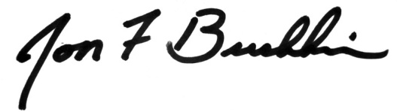
Jon Buchheim
Director

